11.1 Acids and bases
Name: ____________________ Class: ____________________ Due date: 12.29
1. Which substance is the most acidic? （ ）
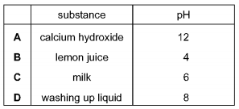
2. Different plants grow best under different pH conditions.
Which plant grows worst in acidic soil? （ ）
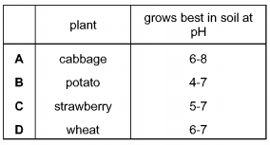

3. The graph shows how the pH of soil in a field changes over time.
At which point was the soil neutral? （ ）
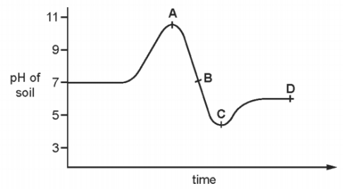

4. Which of the following solution has the highest concentration of H+ ? （ ）
A. HCl(aq) with ph of 2 B. H₂SO₄ with ph of 3 C. NaOH with ph of 9

5. Which of the following solution has the lowest PH
A. HCl with 1mol/cm3 concentration of H+
B. H₂SO₄ with 0.002mol/dm3 concentration of H+
C. NaOH with 0.00002mol/dm3 concentration of H+
D. HNO₃ with 0.3mol/dm3 concentration of H+

6.Which of the following solution shows the lowest acidity? （ ）
A. HCl solution with ph of 2
B. CH₃COOH solution with ph of 3
C. Na₂CO₃ solution with ph of 8
D. NaOH solution with ph of 14

7.(Extension).
A sting from insect X has a pH of 6 and a sting from insect Y has a pH of 8.
The table shows the pH of four substances.
The effect of acidic substances can be canceled by substance with ph higher than 7
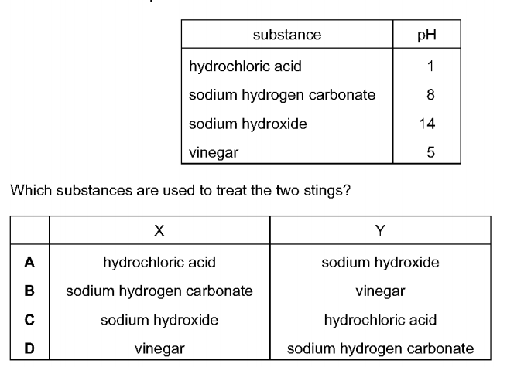
Which substances are used to treat the two stings? （ ）

1. Two indicators, bromophenol blue and Congo red, show the following colours in acidic solutions and in alkaline solutions.
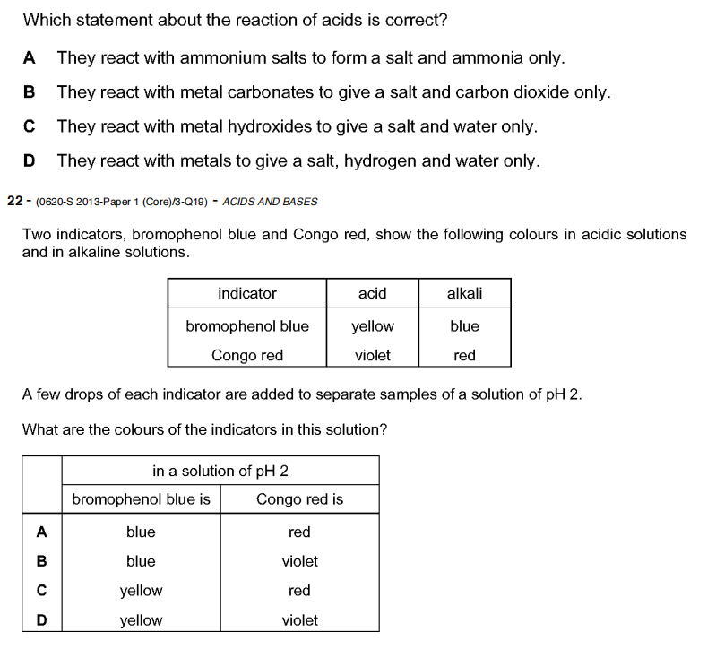
A few drops of each indicator are added to separate samples of a solution of pH 2.
What are the colours of the indicators in this solution? （ ）
2. The table shows the pH of four aqueous solutions, W, X, Y and Z.
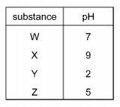
Universal Indicator is added to each solution.
Which row shows the colour of each solution after the indicator is added? （ ）
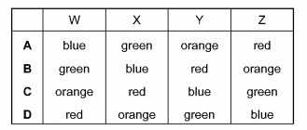

$0.1 {\text{mol/dm}}^{3}$$0.1 {\text{mol/dm}}^{3}$$0.1 {\text{mol/dm}}^{3}$$0.1 {\text{mol/dm}}^{3}$3. Which solution has the lowest pH? （ ）
A ammonia solution
B ethanoic acid
C lithium hydroxide
D nitric acid

4. Potassium hydroxide is a base.
Which statement describes a reaction of potassium hydroxide? （ ）
A Chlorine is formed when it is heated with ammonium chloride.
B It turns Universal Indicator green.
C It reacts with an acid to produce a salt and water.
D It turns methyl orange red.

5. Which row shows the difference between a weak acid and a strong acid? （ ）
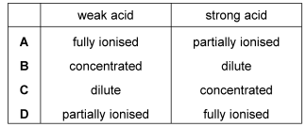
6. Which statement describes the properties of hydrochloric acid? （ ）
A Carbon dioxide is produced when limestone reacts with hydrochloric acid.
B Hydrogen is produced when sodium hydroxide reacts with hydrochloric acid.
C Methyl orange turns yellow in strong hydrochloric acid.
D Red litmus paper turns blue when dipped into hydrochloric acid.

7. What is a characteristic of acids? （ ）
A Acids turn methyl orange indicator yellow.
B Acids have a high pH value.
C Acids react with ammonium salts to give ammonia gas.
D Acids react with carbonates to produce salts.

8. Which of the following solution shows the lowest acidity? （ ）
A. HCl solution with ph of 2
B. CH₃COOH solution with ph of 3
C. Na₂CO₃ solution with ph of 8
D. NaOH solution with ph of 14
9. Which substance is the most alkaline? （ ）

10. Which of the following solution shows the lowest acidity? （ ）
A. HCl solution with ph of 2
B. CH₃COOH solution with ph of 3
C. Na₂CO₃ solution with ph of 8
D. NaOH solution with ph of 14

8. Solution A has a higher concentration of H⁺ ions than solution B does.
Which has a higher pH, A or B?

9. Solutions of acids X and Y have the same concentrations.
X has pH 2.5. Y has pH 5.3. Which one is a weak acid?

10. A solution of a strong acid has a pH of 2.
How will the pH change when you add more water? Explain your answer.

11. Please complete the reaction for dissociation of the following acids
（The first blank is for the symbol , the last is for the product)
(a) HNO₃ H+ +
(b) H₂SO₄ 2H+ +
(c) HCl H+ +
(d) H₂CO₃ 2H+ +
(e) CH₃COOH H+ +

